Local Press release Final
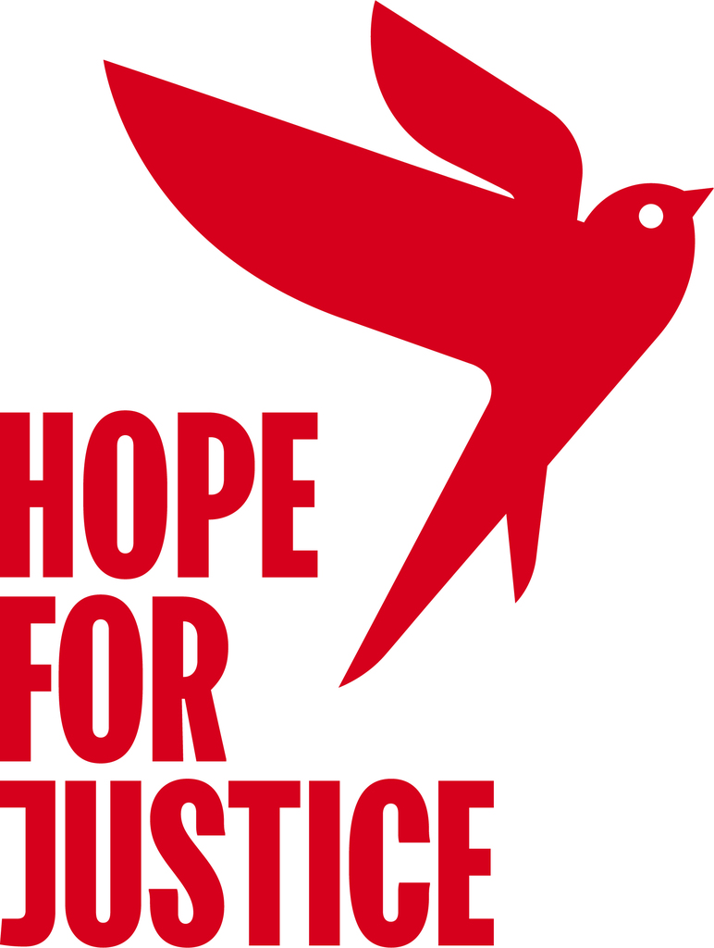
For Immediate release

One man, two dogs, 365 marathons, 10,000 miles and counting.

Our local resident, Aaron Robinson has been running a marathon with his two dogs River and Inca every single day to raise money for Hope for Justice, a charity that aims to end human trafficking and modern slavery, and to draw attention to the approximately 50 million women, men and children trapped in modern slavery today.

For the year's landmark he will be joined by fellow athletes and supporters for his 365th marathon run on Sunday 17th December around Newham and Waltham Forest in East London.

Aaron wakes up at 3am and heads out with his head torch, a hydration vest, running gels and a packet of crisps to start his off-road marathon around the London boroughs of Newham and Waltham Forest. Each marathon takes around five hours and he finishes just in time to start his working day at 9am and is in bed by 7pm to rest and recharge in order to be able to do it again the next morning.
“I’m using my passion of running to help those who can’t run away from their exploitation. People who are forced into sex work, or controlled by another person over where they live, work and sleep. Running a marathon each day is nothing compared to what victims and survivors of human trafficking go through, so that helps put what I’m doing into perspective.”
For anyone who’s trained for a marathon you will appreciate how gruelling the training is, never mind the relief when it’s over. Imagine running it again and again for an entire year!

“I didn’t think I would get to 365 when I started. But my dogs help me get through the challenge. Unlike me, they never complain about the weather and they always get excited when they know it’s time to run. It feels like we’re a pack, so if they want to run each day, it would be rude not to join them. I want to keep going and do as many marathons as I can now.”

’I’ve been so touched by all the support I’ve received. Thank you so much to everyone who is supporting me and as I head for the year milestone and eventually the world record. They give me the boost to keep going.’

If you would like to run the marathon with Aaron on Sunday 17th you can meet him at the Harrow Road Pavilion on Wanstead flats at 7am or if you want to run a half marathon you can meet him at the pavilion at 9.30am. If you would like to cheer him on for his last lap then he’ll be finishing at the pavilion at midday.

Aaron’s not stopping at 365 days on Sunday 17th December, he’s hoping to break the world record of 607 consecutive marathons which will hopefully be on 16th August 2024.

Aaron is asking people to donate via his just giving page here.

- Ends-

NOTE FOR EDITORS

Just giving page https://justgiving.com/page/mycrazycollies

Exact calculations for distance is 9,563 miles / 15,403 km running for 365 days

About Hope for Justice

Founded in the UK in 2008, Hope for Justice is an international charity working across the world. We help victims and survivors directly and also bring about long-term change through our work with governments, law enforcement, the business community and the general public.

On 20 November 23 Hope for Justice won .org impact charity of the year. Read article here

For more information about Hope for Justice please contact,
Adam Hewitt, Head of Digital and Communications.
Email address: adam.hewitt@hopeforjustice.org
www.hopeforjustice.org

For more information about Aaron’s story please contact
Aaron Robinson, Internal Communications Manager
Email address: aaron.robinson@hopeforjustice.org
Mobile number: 07542783839

